Shoulder joint
- Also called Glenohumeral joint
- Most mobile joint
[NOTE]As a consequence of its flexibility, shoulder joint is unstable – prone for dislocation

Articulating surfaces:
- glenoid cavity of scapula with head of humerus
- glenoid labrum deepens the cavity of cavity

Orientation of the joint:
- Head of humerus is oriented at 45⁰ from the long axis of the shaft and retroverted 30⁰.
- The shallow shaped glenoid cavity is retroverted and inferiorly angulated 5⁰ from the long axis of scapula

Type of joint:
- ball and socket synovial joint

Capsule of joint
[NOTE]Encloses tendon of long head of biceps.
[CLINICAL]Knee joint with tendon of popliteus is the only other intracapsular tendon

- Medially – to margins of glenoid cavity
- Laterally – to anatomical neck 1.5 cm on surgical neck
- Inferior attachment to humerus extends
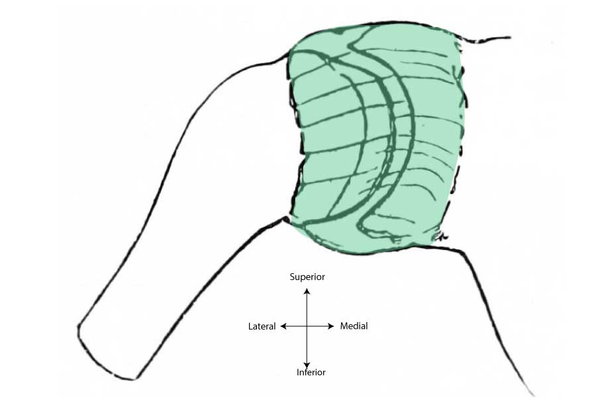
[WARNING]Portion of epiphyseal line of proximal humerus is intracapsular – septic arthritis of the shoulder joint may occur following metaphyseal osteomyelitis

Synovial membrane
Lines the inner aspect of joint capsule. Projects along the tendon of long head of biceps. Communicates with few bursae.

Ligaments
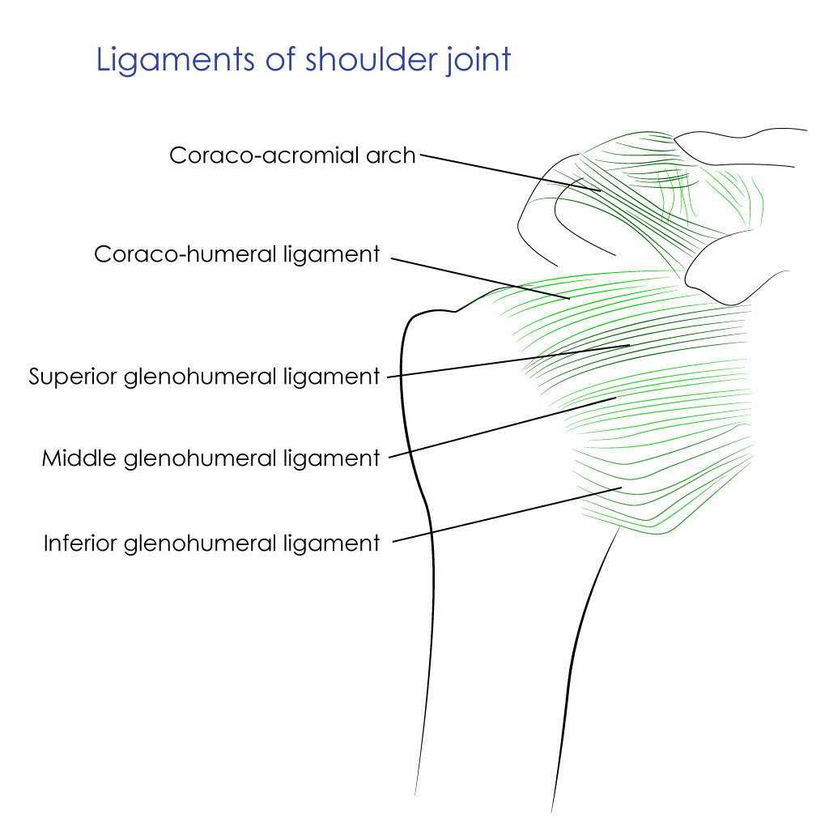

Glenohumeral ligaments
- Superior
- Middle
- Inferior
[CLINICAL]Gap between superior and middle glenohumeral ligaments is of noted significance in anterior dislocation of shoulder

Coracohumeral ligament
  - From base of coracoid process to anterior aspect of greater tubercle of humerus
- Transverse humeral ligament – bridges the bicipital groove. Tendon of long head of biceps brachi passes beneath this ligament
- Coracoclavicular - accessory ligament
- Coracoacromial arch - an osseoligamentous arch around the head of humerus; subarachnoid bursa located superior to this arch
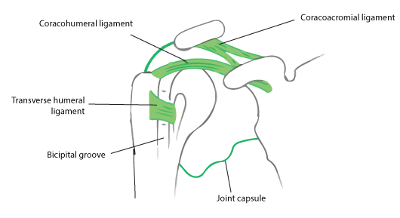

Bursae related to shoulder joint
- Subscapular bursa: lies between the tendon of subscapulris and neck of scapula
- Subacromial (subdeltoid) bursa: between coracoaromial ligament and acromian process above; and supraspinatus below
- Infraspinatus bursa: between tendon of infraspinatus and joint capsule

Relations of shoulder joint
- Superiorly: coracoacromial arch, subacromial bursa, supraspinatus and deltoid
- Inferiorly: long head of triceps, axillary nerve and posterior circumflex humeral vessels
- Anteriorly: subscapularis, subacromial bursa, coracobrachialis, short head of biceps and deltoid
- Posteriorly: infrapinatus, teres minor and deltoid

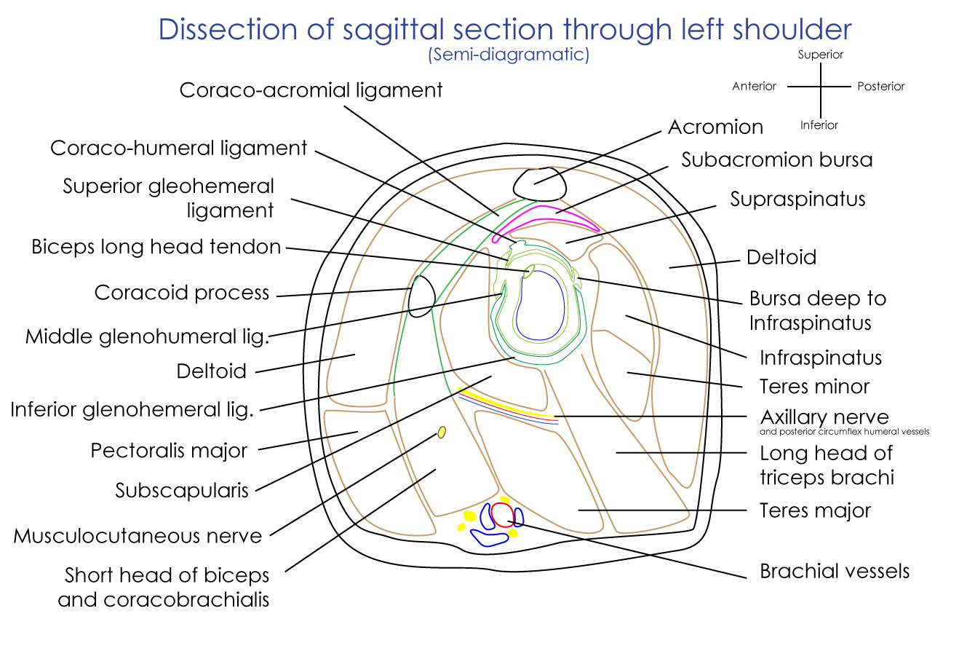
[IMP]Learn to draw the diagram
[YOUTUBE] https://youtu.be/Whqbwbog0yE

Nerve supply: axillary nerve, suprascapular nerve and musuclocutaneous nerve

Stability of shoulder joint
- Rotator cuff muscles
- Coracoacromial arch – forms secondary socket for glenohumeral joint
- Long head of biceps
- Glenoid labrum – deepens the shallow of glenoid cavity
Applied aspects:
Shoulder is more vulnerable for dislocation than any other joint
Fall on the outstretched hand with shoulder abducted and externally rotated dislocates shoulder anteriorly.
- Recurrent anterior shoulder dislocation – abnormal anatomical factors responsible
  - Hill-Sach’s lesion – posterolateral lesion in head of humerus
  - Bankart’s lesion – anterior part of glenoid labrum
  - Erosion of anterior rim of glenoid cavity

Frozen shoulder
Definition – painful restriction of both active and passive shoulder movements due to causes within the shoulder joint or remote
Causes of frozen shoulder are tendinitis of rotator cuff, bicipital tendinitis, fractures and dislocations around shoulder.
Rotator cuff lesions – are usually associated with supraspinatus tendon.

